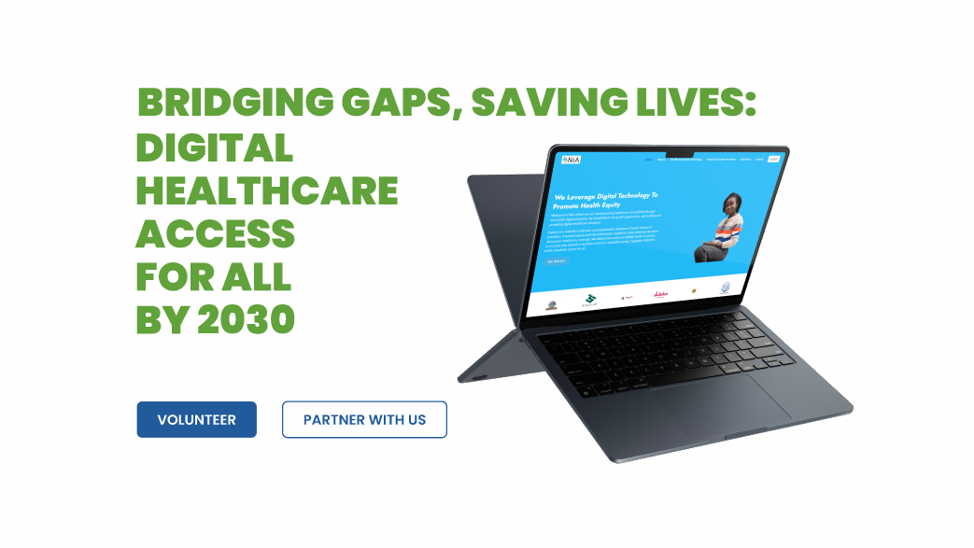

**CTA (volunteer)** -> external link to https://docs.google.com/forms/d/e/1FAIpQLSdsC_ebsdqIyzcBbyhaXA4memOQnIBje_HTtcpz3bWsMkDeoQ/viewform

**Partner with us** -> link to the CONTACT section